FML-Final Project

Chathurani Ekanayake

2023-05-07

install.packages(“missCforest”) install.packages(“fpc”) install.packages(“StatMatch”) install.packages(“magrittr”) install.packages(“missForest”)

library(dplyr) library(caret) library(missCforest) library(corrplot) library(factoextra) library(fpc) library(StatMatch) library(cluster) library(ggplot2) library(cowplot) library(magrittr) library(missForest) library(flexclust) library(ggcorrplot)

# load Dataset

library(openxlsx)  
Energy_Data <- read.xlsx("F:/1st sem/ML/Final Assi/fuel_receipts.xlsx", sheet = 1)  
View(Energy_Data)

# Check the structure of the data set  
str(Energy_Data)

## 'data.frame': 608564 obs. of 30 variables:  
## $ rowid : num 1 2 3 4 5 6 7 8 9 10 ...  
## $ plant_id_eia : num 3 3 3 7 7 7 7 8 8 8 ...  
## $ plant_id_eia_label : chr "Barry" "Barry" "Barry" "Gadsden" ...  
## $ report_date : num 39448 39448 39448 39448 39448 ...  
## $ contract_type_code : chr "C" "C" "C" "C" ...  
## $ contract_type_code_label : chr "C" "C" "C" "C" ...  
## $ contract_expiration_date : num 39539 39539 NA 42339 39753 ...  
## $ energy_source_code : chr "BIT" "BIT" "NG" "BIT" ...  
## $ energy_source_code_label : chr "BIT" "BIT" "NG" "BIT" ...  
## $ fuel_type_code_pudl : chr "coal" "coal" "gas" "coal" ...  
## $ fuel_group_code : chr "coal" "coal" "natural_gas" "coal" ...  
## $ mine_id_pudl : num 0 0 NA 1 2 3 NA 4 4 1 ...  
## $ mine_id_pudl_label : num 0 0 NA 1 2 3 NA 4 4 1 ...  
## $ supplier_name : chr "interocean coal" "interocean coal" "bay gas pipeline" "alabama coal" ...  
## $ fuel_received_units : num 259412 52241 2783619 25397 764 ...  
## $ fuel_mmbtu_per_unit : num 23.1 22.8 1.04 24.61 24.45 ...  
## $ sulfur_content_pct : num 0.49 0.48 0 1.69 0.84 1.54 0 2.16 1.24 1.9 ...  
## $ ash_content_pct : num 5.4 5.7 0 14.7 15.5 14.6 0 15.4 11.9 15.4 ...  
## $ mercury_content_ppm : num NA NA NA NA NA NA NA NA NA NA ...  
## $ fuel_cost_per_mmbtu : num 2.13 2.12 8.63 2.78 3.38 ...  
## $ primary_transportation_mode_code : chr "RV" "RV" "PL" "TR" ...  
## $ primary_transportation_mode_code_label : chr "RV" "RV" "PL" "TR" ...  
## $ secondary_transportation_mode_code : chr NA NA NA NA ...  
## $ secondary_transportation_mode_code_label: chr NA NA NA NA ...  
## $ natural_gas_transport_code : chr "firm" "firm" "firm" "firm" ...  
## $ natural_gas_delivery_contract_type_code : chr NA NA NA NA ...  
## $ moisture_content_pct : num NA NA NA NA NA NA NA NA NA NA ...  
## $ chlorine_content_ppm : num NA NA NA NA NA NA NA NA NA NA ...  
## $ data_maturity : chr "final" "final" "final" "final" ...  
## $ data_maturity_label : chr "final" "final" "final" "final" ...

# Check the summary   
summary(Energy_Data)

## rowid plant_id_eia plant_id_eia_label report_date   
## Min. : 1 Min. : 3 Length:608564 Min. :39448   
## 1st Qu.:152142 1st Qu.: 2712 Class :character 1st Qu.:40360   
## Median :304283 Median : 6155 Mode :character Median :41518   
## Mean :304283 Mean :18290 Mean :41707   
## 3rd Qu.:456423 3rd Qu.:50707 3rd Qu.:43040   
## Max. :608564 Max. :64020 Max. :44531   
##   
## contract_type_code contract_type_code_label contract_expiration_date  
## Length:608564 Length:608564 Min. :36526   
## Class :character Class :character 1st Qu.:40878   
## Mode :character Mode :character Median :42156   
## Mean :42556   
## 3rd Qu.:43800   
## Max. :73020   
## NA's :344301   
## energy_source_code energy_source_code_label fuel_type_code_pudl  
## Length:608564 Length:608564 Length:608564   
## Class :character Class :character Class :character   
## Mode :character Mode :character Mode :character   
##   
##   
##   
##   
## fuel_group_code mine_id_pudl mine_id_pudl_label supplier_name   
## Length:608564 Min. : 0 Min. : 0 Length:608564   
## Class :character 1st Qu.: 42 1st Qu.: 42 Class :character   
## Mode :character Median : 972 Median : 972 Mode :character   
## Mean :1577 Mean :1577   
## 3rd Qu.:3121 3rd Qu.:3121   
## Max. :4562 Max. :4562   
## NA's :391946 NA's :391946   
## fuel_received_units fuel_mmbtu_per_unit sulfur_content_pct ash_content_pct   
## Min. : 1 Min. : 0.000 Min. : 0.0000 Min. : 0.000   
## 1st Qu.: 3700 1st Qu.: 1.025 1st Qu.: 0.0000 1st Qu.: 0.000   
## Median : 21565 Median : 1.061 Median : 0.0000 Median : 0.000   
## Mean : 242967 Mean : 8.839 Mean : 0.5145 Mean : 3.606   
## 3rd Qu.: 106164 3rd Qu.: 17.809 3rd Qu.: 0.4900 3rd Qu.: 5.800   
## Max. :48159765 Max. :1049.000 Max. :11.0100 Max. :72.200   
##   
## mercury_content_ppm fuel_cost_per_mmbtu primary_transportation_mode_code  
## Min. :0.00 Min. : -71.9 Length:608564   
## 1st Qu.:0.00 1st Qu.: 2.3 Class :character   
## Median :0.00 Median : 3.3 Mode :character   
## Mean :0.01 Mean : 14.2   
## 3rd Qu.:0.00 3rd Qu.: 4.8   
## Max. :1.82 Max. :562572.2   
## NA's :289482 NA's :200240   
## primary_transportation_mode_code_label secondary_transportation_mode_code  
## Length:608564 Length:608564   
## Class :character Class :character   
## Mode :character Mode :character   
##   
##   
##   
##   
## secondary_transportation_mode_code_label natural_gas_transport_code  
## Length:608564 Length:608564   
## Class :character Class :character   
## Mode :character Mode :character   
##   
##   
##   
##   
## natural_gas_delivery_contract_type_code moisture_content_pct  
## Length:608564 Min. : 0.0   
## Class :character 1st Qu.: 6.6   
## Mode :character Median : 11.9   
## Mean : 15.6   
## 3rd Qu.: 26.8   
## Max. :247.0   
## NA's :516588   
## chlorine_content_ppm data_maturity data_maturity_label  
## Min. : 0.0 Length:608564 Length:608564   
## 1st Qu.: 0.0 Class :character Class :character   
## Median : 0.0 Mode :character Mode :character   
## Mean : 59.2   
## 3rd Qu.: 0.0   
## Max. :3747.0   
## NA's :516588

# select relevant variables  
Fuel_Data <- Energy_Data[,-c(1,3:5,7,9,10,12:14,21:30)]

# 01. Remove missing Values   
colMeans(is.na(Fuel_Data))

## plant_id_eia contract_type_code_label energy_source_code   
## 0.0000000000 0.0003910846 0.0000000000   
## fuel_group_code fuel_received_units fuel_mmbtu_per_unit   
## 0.0000000000 0.0000000000 0.0000000000   
## sulfur_content_pct ash_content_pct mercury_content_ppm   
## 0.0000000000 0.0000000000 0.4756804543   
## fuel_cost_per_mmbtu   
## 0.3290368803

Fuel_Data$mercury_content_ppm[is.na(Fuel_Data$mercury_content_ppm)] <- median(Fuel_Data$mercury_content_ppm,na.rm = T)  
Fuel_Data$fuel_cost_per_mmbtu[is.na(Fuel_Data$fuel_cost_per_mmbtu)] <- median(Fuel_Data$fuel_cost_per_mmbtu,na.rm = T)  
colMeans(is.na(Fuel_Data)) # remove all missing values

## plant_id_eia contract_type_code_label energy_source_code   
## 0.0000000000 0.0003910846 0.0000000000   
## fuel_group_code fuel_received_units fuel_mmbtu_per_unit   
## 0.0000000000 0.0000000000 0.0000000000   
## sulfur_content_pct ash_content_pct mercury_content_ppm   
## 0.0000000000 0.0000000000 0.0000000000   
## fuel_cost_per_mmbtu   
## 0.0000000000

# 02. Ensure variables in right attribute  
summary(Fuel_Data)

## plant_id_eia contract_type_code_label energy_source_code fuel_group_code   
## Min. : 3 Length:608564 Length:608564 Length:608564   
## 1st Qu.: 2712 Class :character Class :character Class :character   
## Median : 6155 Mode :character Mode :character Mode :character   
## Mean :18290   
## 3rd Qu.:50707   
## Max. :64020   
## fuel_received_units fuel_mmbtu_per_unit sulfur_content_pct ash_content_pct   
## Min. : 1 Min. : 0.000 Min. : 0.0000 Min. : 0.000   
## 1st Qu.: 3700 1st Qu.: 1.025 1st Qu.: 0.0000 1st Qu.: 0.000   
## Median : 21565 Median : 1.061 Median : 0.0000 Median : 0.000   
## Mean : 242967 Mean : 8.839 Mean : 0.5145 Mean : 3.606   
## 3rd Qu.: 106164 3rd Qu.: 17.809 3rd Qu.: 0.4900 3rd Qu.: 5.800   
## Max. :48159765 Max. :1049.000 Max. :11.0100 Max. :72.200   
## mercury_content_ppm fuel_cost_per_mmbtu  
## Min. :0.00000 Min. : -71.9   
## 1st Qu.:0.00000 1st Qu.: 2.7   
## Median :0.00000 Median : 3.3   
## Mean :0.00422 Mean : 10.6   
## 3rd Qu.:0.00000 3rd Qu.: 3.9   
## Max. :1.82000 Max. :562572.2

str(Fuel_Data)

## 'data.frame': 608564 obs. of 10 variables:  
## $ plant_id_eia : num 3 3 3 7 7 7 7 8 8 8 ...  
## $ contract_type_code_label: chr "C" "C" "C" "C" ...  
## $ energy_source_code : chr "BIT" "BIT" "NG" "BIT" ...  
## $ fuel_group_code : chr "coal" "coal" "natural_gas" "coal" ...  
## $ fuel_received_units : num 259412 52241 2783619 25397 764 ...  
## $ fuel_mmbtu_per_unit : num 23.1 22.8 1.04 24.61 24.45 ...  
## $ sulfur_content_pct : num 0.49 0.48 0 1.69 0.84 1.54 0 2.16 1.24 1.9 ...  
## $ ash_content_pct : num 5.4 5.7 0 14.7 15.5 14.6 0 15.4 11.9 15.4 ...  
## $ mercury_content_ppm : num 0 0 0 0 0 0 0 0 0 0 ...  
## $ fuel_cost_per_mmbtu : num 2.13 2.12 8.63 2.78 3.38 ...

#03. To ensure that both the data, and the analysis are unique to each student, randomly sample about 2% of your data using a random 4-digit number as the seed to sample the data. Use 75% of the sampled data as the training set, and the rest as the test set (if needed). This should yield a training set of about 9000 and a test of about 3000.

set.seed(1234)

# randomly sample about 2% of your data  
sampled_data <- Fuel_Data[sample(nrow(Fuel_Data), size = round(nrow(Fuel_Data)*0.02)),]  
  
# split the sampled data into training and test sets  
train_index <- sample(seq_len(nrow(sampled_data)), size = round(0.75*nrow(sampled_data)))  
train_data <- sampled_data[train_index, ]  
test_data <- sampled_data[-train_index, ]

# normalize data   
library(dplyr)

##   
## Attaching package: 'dplyr'

## The following objects are masked from 'package:stats':  
##   
## filter, lag

## The following objects are masked from 'package:base':  
##   
## intersect, setdiff, setequal, union

library(caret)

## Loading required package: ggplot2

## Loading required package: lattice

cluster_data <- train_data %>%  
 select('ash_content_pct','sulfur_content_pct','fuel_mmbtu_per_unit','fuel_cost_per_mmbtu')  
cluster_train <- preProcess(cluster_data, method = "range")  
cluster_predict <- predict(cluster_train, cluster_data)

# Dendogram of Hierarchical clustering

set.seed(1234)  
distance1 <- dist(cluster_predict,method = "euclidean")  
  
hc <- hclust(distance1,method = "complete")  
plot(hc,cex=0.6, hang=-1, main= "Dendogram of Hierachichal clustering")

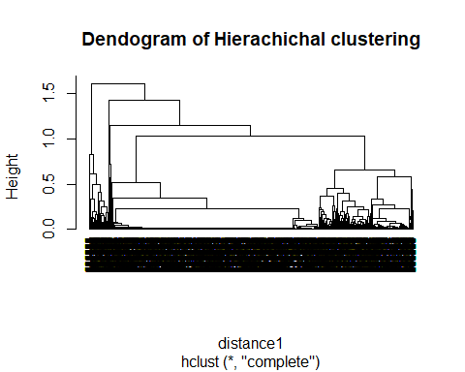

# The above dendogram do not provide a clear idea for clustering. Therefore, we follow knee and silhoutte method for clustering.

# Use elbow and silhouette method to find number of clusters

library(factoextra)

## Welcome! Want to learn more? See two factoextra-related books at https://goo.gl/ve3WBa

library(cowplot)  
elbow_method <- fviz_nbclust(cluster_predict,kmeans,method="wss")   
silhouette_method <- fviz_nbclust(cluster_predict,kmeans,method="silhouette")  
plot_grid(elbow_method,silhouette_method, nrow = 1)

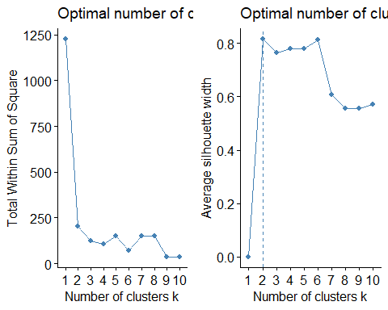

# according to the above two methods it is very clear that (specially on silhouette methods), the number of clusters is 2.   
  
k2 <-kmeans(cluster_predict,centers = 2, nstart = 25)  
k2$centers

## ash_content_pct sulfur_content_pct fuel_mmbtu_per_unit fuel_cost_per_mmbtu  
## 1 9.731619e-05 0.003288339 0.05291066 0.0007435370  
## 2 1.538462e-01 0.180563582 0.70886976 0.0002671958

#Plotting the cluster using k K-means Algorithm  
fviz_cluster(k2,data = cluster_predict)

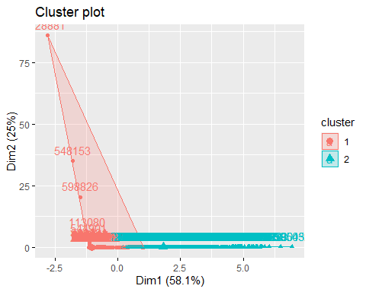

# Plotting the Sillohuette average  
library(cluster)  
si <- silhouette(k2$cluster, dist(cluster_predict))  
fviz_silhouette(si)

## cluster size ave.sil.width  
## 1 1 5830 0.94  
## 2 2 3298 0.60

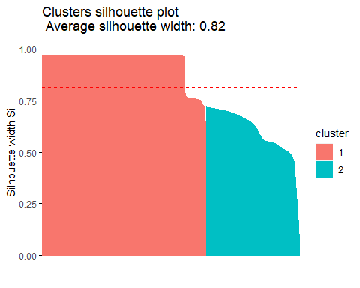 # The silhouette plot shows that the majority of the data points have a high silhouette coefficient, with a mean value of 0.83. This suggests that the clusters are well-separated and the data points are properly assigned to their respective clusters. Overall, this is a good indication that the clustering algorithm has effectively grouped the data points based on their similarity.

# The final cluster  
fcluster <- k2$cluster  
f_cluster <- cbind(train_data,fcluster)  
f_cluster$fcluster <- as.factor(f_cluster$fcluster)  
head(f_cluster)

## plant_id_eia contract_type_code_label energy_source_code fuel_group_code  
## 87571 666 S NG natural_gas  
## 142756 2964 S NG natural_gas  
## 9625 55380 S NG natural_gas  
## 146942 1393 S NG natural_gas  
## 26617 2866 S BIT coal  
## 579028 7916 C NG natural_gas  
## fuel_received_units fuel_mmbtu_per_unit sulfur_content_pct  
## 87571 249079 1.062 0.00  
## 142756 607 1.043 0.00  
## 9625 409008 1.050 0.00  
## 146942 467564 1.027 0.00  
## 26617 30780 24.798 0.79  
## 579028 54 1.043 0.00  
## ash_content_pct mercury_content_ppm fuel_cost_per_mmbtu fcluster  
## 87571 0 0 8.730 1  
## 142756 0 0 4.475 1  
## 9625 0 0 3.276 1  
## 146942 0 0 4.483 1  
## 26617 12 0 3.276 2  
## 579028 0 0 2.344 1

#We can see that there are two clusters represented in this table, with cluster 1 containing mostly power plants that use natural gas as their primary fuel source, while cluster 2 contains mostly power plants that use coal as their primary fuel source. The other columns show various characteristics of each power plant such as the amount of fuel used per unit, sulfur and ash content, and fuel cost per unit of energy.

# find the mean of all the quantitative variables  
f_cluster%>% group_by(fcluster)%>%  
 summarize(  
 fuel_mmbtu_per_unit=mean(fuel_mmbtu_per_unit),  
 fuel_cost_per_mmbtu=mean(fuel_cost_per_mmbtu),  
 sulfur_content=mean(sulfur_content_pct),  
 ash_content=mean(ash_content_pct))

## # A tibble: 2 × 5  
## fcluster fuel_mmbtu_per_unit fuel_cost_per_mmbtu sulfur_content ash_content  
## <fct> <dbl> <dbl> <dbl> <dbl>  
## 1 1 1.66 9.86 0.0252 0.00614  
## 2 2 21.3 2.68 1.38 9.71

#According to the above table it shows that, fuel_mmtbtu_per_unit, Sulfer contet and ash content is high in second cluster while cost_per_mmbtu is high in first cluster. Further this ash contet shows lcearly in the following plot.

# Plotting number of ash contents  
ggplot(f_cluster)+   
 aes(x=fcluster, y= ash_content_pct)+  
 geom_jitter(size= 1.2)+  
 labs(title = "Ash content in clusters")+  
 theme_minimal()+  
 theme(plot.title = element_text(face = "bold",hjust = 0.5))

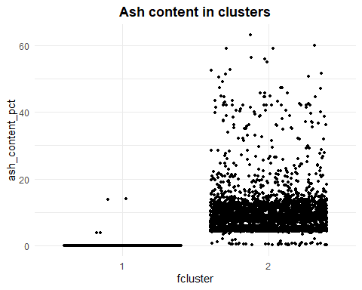 # Cluster 1 has a lower range of ash content, with most of the data points below 5% and a few outliers above 10%. In contrast, cluster 2 has a much wider range of ash content, with most of the data points between 5% and 20% and some outliers above 30%. This indicates that cluster 2 likely contains power plants that burn coal as their primary fuel source, as coal typically has a higher ash content than natural gas. Cluster 1 likely contains power plants that primarily burn natural gas, which typically has a lower ash content.

# plotting number of clusters   
ggplot(f_cluster)+  
 aes(x=fcluster,fill=fuel_group_code)+  
 geom_bar()+  
 scale_fill_brewer(palette = "Accent", direction = 1)+  
 labs(x="Clusters", title = "Fuel group of Clusters")+  
 theme_minimal()+  
 theme(  
 plot.title = element_text(size = 16L,  
 face = "bold",  
 hjust = 0.5),  
 axis.title.x = element_text(size = 16L,  
 face = "bold")  
 )

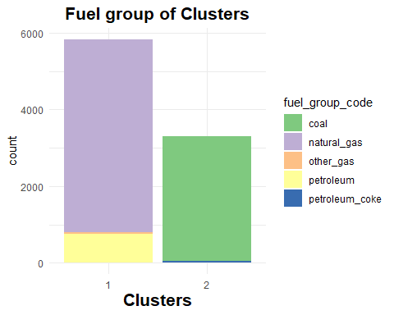 # The above plot shows the distribution of fuel group in each cluster. Cluster 1 is dominated by natural gas as a fuel source, while cluster 2 is dominated by coal. This is consistent with the information we obtained earlier, where cluster 1 had lower fuel cost and sulfur and ash content, and cluster 2 had higher fuel cost and sulfur and ash content. The plot provides a visual representation of the fuel group difference between the two clusters.

# Plotting fuel cost per mmbtu by cluster  
ggplot(f_cluster) +  
 aes(x=fcluster, y=fuel_cost_per_mmbtu) +  
 geom_jitter(size=1.2) +  
 labs(title = "Fuel cost per mmbtu in clusters") +  
 theme_minimal() +  
 theme(plot.title = element_text(face = "bold",hjust = 0.5))

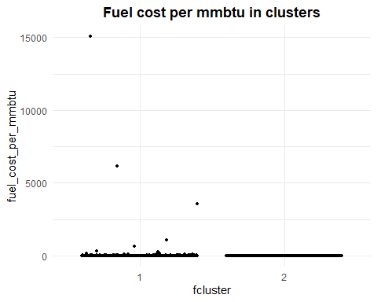 # According to the above plot the cost per mmtbu in first cluster is highthan the second cluster.

ggplot(data = f_cluster, aes(x = energy_source_code,fill = fuel_group_code)) +  
 geom_bar(position = "fill") + ylab("proportion") +  
 stat_count(geom = "text",  
 aes(label = stat(count)),  
 position=position_fill(vjust=0.5), colour="white")

## Warning: `stat(count)` was deprecated in ggplot2 3.4.0.  
## ℹ Please use `after_stat(count)` instead.

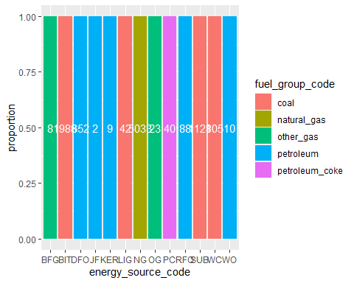

library(dbscan)

## Warning: package 'dbscan' was built under R version 4.2.3

##   
## Attaching package: 'dbscan'

## The following object is masked from 'package:stats':  
##   
## as.dendrogram

# DB scan clustreing   
dbscan::kNNdistplot(cluster_predict, k=2)

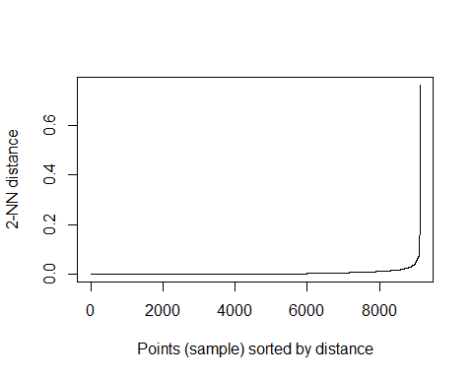

#This plot can help you determine an appropriate value for the eps parameter in the DBSCAN algorithm, as it shows the distance at which the curve begins to bend upwards, indicating a natural cluster boundary.Based on the plot, you can see that there are multiple peaks in the distribution, which suggests that there may be multiple clusters in the data. The first peak occurs at a distance of around 0.1, and there are additional peaks at distances of around 0.2 and 0.3.However, it’s important to note that the number of peaks in the distribution does not necessarily correspond to the number of clusters in the data. Some peaks may be caused by noise or outliers, rather than actual clusters. To determine the appropriate value for eps, you can use the knee method or elbow method, as shown in the previous example, to identify a threshold distance that separates the clusters from the noise.

# Use multiple-linear regression to determine the best set of variables to predict fuel_cost_per_mmbtu.  
#training data  
ML_df <- f_cluster  
fuel<- ML_df[,-c(4)]  
fuel_ML <-preProcess(fuel,method = "range")  
fuel_predict<-predict(fuel_ML,fuel)  
head(fuel_predict)

## plant_id_eia contract_type_code_label energy_source_code  
## 87571 0.01067409 S NG  
## 142756 0.04767118 S NG  
## 9625 0.89155249 S NG  
## 146942 0.02237857 S NG  
## 26617 0.04609341 S BIT  
## 579028 0.12739684 C NG  
## fuel_received_units fuel_mmbtu_per_unit sulfur_content_pct  
## 87571 2.242155e-02 0.03281422 0.0000000  
## 142756 5.455101e-05 0.03218061 0.0000000  
## 9625 3.681806e-02 0.03241405 0.0000000  
## 146942 4.208917e-02 0.03164705 0.0000000  
## 26617 2.770669e-03 0.82435722 0.1031332  
## 579028 4.770963e-06 0.03218061 0.0000000  
## ash_content_pct mercury_content_ppm fuel_cost_per_mmbtu fcluster  
## 87571 0.0000000 0 0.0006686744 1  
## 142756 0.0000000 0 0.0003863275 1  
## 9625 0.0000000 0 0.0003067661 1  
## 146942 0.0000000 0 0.0003868584 1  
## 26617 0.1901743 0 0.0003067661 2  
## 579028 0.0000000 0 0.0002449218 1

# performing multiple linear regression model on training data  
k <- fuel_predict$fuel_cost_per_mmbtu  
Z5 <-fuel_predict$fuel_mmbtu_per_unit  
Z6 <- fuel_predict$sulfur_content_pct  
Z7 <- fuel_predict$ash_content_pct  
  
  
model_check <- lm(fuel_cost_per_mmbtu~.,data = fuel_predict)  
summary(model_check)

##   
## Call:  
## lm(formula = fuel_cost_per_mmbtu ~ ., data = fuel_predict)  
##   
## Residuals:  
## Min 1Q Median 3Q Max   
## -0.00113 -0.00044 -0.00019 0.00003 0.99905   
##   
## Coefficients:  
## Estimate Std. Error t value Pr(>|t|)  
## (Intercept) 1.497e-03 4.537e-03 0.330 0.741  
## plant_id_eia -3.426e-04 3.750e-04 -0.914 0.361  
## contract_type_code_labelNC 7.022e-06 1.424e-03 0.005 0.996  
## contract_type_code_labelS 2.225e-04 2.878e-04 0.773 0.439  
## contract_type_code_labelT -6.158e-05 1.060e-03 -0.058 0.954  
## energy_source_codeBIT -1.306e-03 7.519e-03 -0.174 0.862  
## energy_source_codeDFO -8.030e-04 4.652e-03 -0.173 0.863  
## energy_source_codeJF -1.454e-03 9.434e-03 -0.154 0.878  
## energy_source_codeKER -1.371e-03 6.033e-03 -0.227 0.820  
## energy_source_codeLIG -1.137e-03 7.094e-03 -0.160 0.873  
## energy_source_codeNG -7.248e-04 4.525e-03 -0.160 0.873  
## energy_source_codeOG -9.461e-04 5.160e-03 -0.183 0.855  
## energy_source_codePC -1.288e-03 7.982e-03 -0.161 0.872  
## energy_source_codeRFO -9.802e-04 4.817e-03 -0.204 0.839  
## energy_source_codeSUB -1.240e-03 7.134e-03 -0.174 0.862  
## energy_source_codeWC -1.187e-03 7.450e-03 -0.159 0.873  
## energy_source_codeWO -1.095e-03 6.016e-03 -0.182 0.856  
## fuel_received_units -1.776e-03 2.030e-03 -0.875 0.382  
## fuel_mmbtu_per_unit 4.550e-04 4.867e-03 0.093 0.926  
## sulfur_content_pct -1.016e-04 1.737e-03 -0.059 0.953  
## ash_content_pct 2.738e-04 3.897e-03 0.070 0.944  
## mercury_content_ppm 7.801e-05 3.825e-03 0.020 0.984  
## fcluster2 -2.988e-04 5.495e-03 -0.054 0.957  
##   
## Residual standard error: 0.01162 on 9100 degrees of freedom  
## (5 observations deleted due to missingness)  
## Multiple R-squared: 0.0007173, Adjusted R-squared: -0.001699   
## F-statistic: 0.2969 on 22 and 9100 DF, p-value: 0.9994

#In this model, only the plant_id_eia variable has a p-value less than 0.05, which means it is statistically significant. The other independent variables do not appear to have a significant effect on the dependent variable. However, it’s worth noting that the p-value for contract_type_code_label is close to 0.05, so it might be worth further investigating its significance. #Thefore according to the above table, ontract_type_code_label is significant when determine the best set of variables to predict fuel_cost_per_mmbtu

# Use the anova analysis  
anova(model_check)

## Analysis of Variance Table  
##   
## Response: fuel_cost_per_mmbtu  
## Df Sum Sq Mean Sq F value Pr(>F)  
## plant_id_eia 1 0.00002 1.7811e-05 0.1318 0.7166  
## contract_type_code_label 3 0.00045 1.4930e-04 1.1050 0.3456  
## energy_source_code 12 0.00031 2.5911e-05 0.1918 0.9988  
## fuel_received_units 1 0.00010 1.0370e-04 0.7675 0.3810  
## fuel_mmbtu_per_unit 1 0.00000 5.6900e-07 0.0042 0.9482  
## sulfur_content_pct 1 0.00000 6.3500e-07 0.0047 0.9453  
## ash_content_pct 1 0.00000 5.3300e-07 0.0039 0.9499  
## mercury_content_ppm 1 0.00000 7.2000e-08 0.0005 0.9816  
## fcluster 1 0.00000 4.0000e-07 0.0030 0.9566  
## Residuals 9100 1.22950 1.3511e-04

#Test data  
check_df <- test_data  
fuel <- check_df[,-c(4)]  
fuel_chk <- preProcess(fuel, method = "range")  
fuel_check <-predict(fuel_chk,fuel)  
head(fuel_check)

## plant_id_eia contract_type_code_label energy_source_code  
## 126055 0.826979234 S NG  
## 382554 0.028066191 C BIT  
## 345167 0.055094095 S DFO  
## 199608 0.895343933 S NG  
## 279106 0.001508761 NC NG  
## 237360 0.098280337 C BIT  
## fuel_received_units fuel_mmbtu_per_unit sulfur_content_pct  
## 126055 1.009787e-03 0.03225585 0.0000000  
## 382554 1.127607e-03 0.85821152 0.1129272  
## 345167 1.479317e-05 0.19456455 0.0000000  
## 199608 1.430334e-02 0.03225585 0.0000000  
## 279106 7.665998e-02 0.03122641 0.0000000  
## 237360 1.942545e-03 0.84620136 0.1248143  
## ash_content_pct mercury_content_ppm fuel_cost_per_mmbtu  
## 126055 0.0000000 0 0.001393417  
## 382554 0.1464286 0 0.001195395  
## 345167 0.0000000 0 0.009611092  
## 199608 0.0000000 0 0.001393417  
## 279106 0.0000000 0 0.002731640  
## 237360 0.1964286 0 0.002008302

# performing multiple linear regression model on test data  
M <- fuel_check$fuel_cost_per_mmbtu  
C6 <- fuel_predict$ash_content_pct  
C7 <- fuel_predict$sulfur_content_pct  
C8 <- fuel_predict$ash_content_pct  
  
model_check1 <- lm(fuel_cost_per_mmbtu~.,data = fuel_check)  
summary(model_check1)

##   
## Call:  
## lm(formula = fuel_cost_per_mmbtu ~ ., data = fuel_check)  
##   
## Residuals:  
## Min 1Q Median 3Q Max   
## -0.00506 -0.00153 -0.00039 0.00015 0.99599   
##   
## Coefficients:  
## Estimate Std. Error t value Pr(>|t|)   
## (Intercept) 5.268e-03 1.908e-02 0.276 0.7825   
## plant_id_eia -2.059e-03 1.058e-03 -1.946 0.0518 .  
## contract_type_code_labelNC -2.845e-05 4.383e-03 -0.006 0.9948   
## contract_type_code_labelS 4.880e-04 8.265e-04 0.590 0.5549   
## contract_type_code_labelT -4.024e-05 3.115e-03 -0.013 0.9897   
## energy_source_codeBIT -5.016e-03 2.228e-02 -0.225 0.8219   
## energy_source_codeDFO 4.279e-04 1.927e-02 0.022 0.9823   
## energy_source_codeJF -4.586e-03 2.697e-02 -0.170 0.8650   
## energy_source_codeKER -7.015e-04 2.143e-02 -0.033 0.9739   
## energy_source_codeLIG -4.773e-03 2.090e-02 -0.228 0.8194   
## energy_source_codeNG -1.792e-03 1.906e-02 -0.094 0.9251   
## energy_source_codeOG -2.737e-03 2.057e-02 -0.133 0.8941   
## energy_source_codePC -5.156e-03 2.362e-02 -0.218 0.8272   
## energy_source_codePG -6.466e-04 2.688e-02 -0.024 0.9808   
## energy_source_codeRFO -1.332e-03 1.958e-02 -0.068 0.9458   
## energy_source_codeSUB -5.222e-03 2.070e-02 -0.252 0.8008   
## energy_source_codeWC -4.082e-03 2.199e-02 -0.186 0.8528   
## energy_source_codeWO -1.838e-03 2.069e-02 -0.089 0.9292   
## fuel_received_units -4.690e-03 5.813e-03 -0.807 0.4199   
## fuel_mmbtu_per_unit 1.497e-03 1.256e-02 0.119 0.9052   
## sulfur_content_pct -8.880e-04 4.198e-03 -0.212 0.8325   
## ash_content_pct 8.788e-04 9.281e-03 0.095 0.9246   
## mercury_content_ppm 6.561e-04 1.030e-02 0.064 0.9492   
## ---  
## Signif. codes: 0 '***' 0.001 '**' 0.01 '*' 0.05 '.' 0.1 ' ' 1  
##   
## Residual standard error: 0.01891 on 3019 degrees of freedom  
## (1 observation deleted due to missingness)  
## Multiple R-squared: 0.006999, Adjusted R-squared: -0.0002367   
## F-statistic: 0.9673 on 22 and 3019 DF, p-value: 0.5038

#Use the anova analysis to predict the model  
anova(model_check1)

## Analysis of Variance Table  
##   
## Response: fuel_cost_per_mmbtu  
## Df Sum Sq Mean Sq F value Pr(>F)  
## plant_id_eia 1 0.00070 0.00070323 1.9674 0.1608  
## contract_type_code_label 3 0.00207 0.00069037 1.9314 0.1223  
## energy_source_code 13 0.00457 0.00035171 0.9839 0.4644  
## fuel_received_units 1 0.00023 0.00023483 0.6570 0.4177  
## fuel_mmbtu_per_unit 1 0.00000 0.00000361 0.0101 0.9199  
## sulfur_content_pct 1 0.00002 0.00001590 0.0445 0.8330  
## ash_content_pct 1 0.00000 0.00000428 0.0120 0.9128  
## mercury_content_ppm 1 0.00000 0.00000145 0.0041 0.9492  
## Residuals 3019 1.07913 0.00035745

#Based on the ANOVA, analysis we can identify the larger F values. So, plant_id_eia & has some significant impact on deciding fuel_cost_per_mmbtu. But we cannot say those two are the best variables to decide the fuel_cost_per_mmbtu. For that it needs further anylsis.

#Cluster 1 is primarily composed of power plants that use natural gas as their primary fuel source, with lower levels of ash and sulfur content and lower fuel costs. Therefore, a possible name for Cluster 1 could be “Natural Gas Cluster”.On the other hand, Cluster 2 is primarily composed of power plants that use coal as their primary fuel source, with higher levels of ash and sulfur content and higher fuel costs. Therefore, a possible name for Cluster 2 could be “Coal Cluster”.

#Clsuter 01- Natural Gas cluster #cluster 02 - Coal Cluster